

PARSHVANATH CHARITABLE TRUST'S
- P. Shah Institute of Technology
Thane, 400615

Academic Year: 2022-23
Department of Computer Engineering

CSL605 SKILL-BASED LAB COURSE: CLOUD COMPUTING

Mini Project Report

- Title of Project: Employee Profile :

- Year and Semester: T.E. (Sem VI)

- Group Members: Roll No. Name
49 Chaitali Sule
61 Shriya Vidwans

1

Table of Contents
Sr. No. | Topic | Page No.
1. | Abstract | 3
2. | Introduction | 4
3. | Problem Definition | 5
4. | Objective & Scope | 6
5. | Description | 7
6. | Implementation details with screen-shots (stepwise) | 9
7. | Learning Outcome | 15

2
Abstract

The "Employee Profile" website project is an example of a cloud-based application that leverages AWS cloud services to provide a secure and scalable platform for employees to create, save, view, and modify their profiles. The project uses AWS Lambda, API Gateway, DynamoDB, S3 bucket, and CloudFront to store and retrieve employee data, handle HTTP requests, distribute static content, and ensure high availability and scalability.
AWS Lambda is used to execute serverless code functions, and API Gateway is used to create RESTful APIs to access the backend resources. The Lambda function interacts with the DynamoDB database to retrieve or modify the employee data, and the API Gateway triggers the Lambda function based on the HTTP request method received.
The website's static content, such as HTML, CSS, and JavaScript files, is stored in an S3 bucket, and CloudFront is used as a content delivery network to distribute the static content globally, ensuring fast and reliable access to the website by users worldwide.
Overall, the "Employee Profile" website demonstrates how cloud-based applications can leverage AWS cloud services to provide secure, scalable, and efficient platforms for users to access and manage data. These cloud services enable organizations to focus on their core competencies while AWS handles the infrastructure and platform management.

3
Introduction

With the increasing need for remote work and digital solutions, cloud-based applications have become essential for businesses and organizations to manage their data and resources efficiently. This website project demonstrates how cloud-based applications can leverage AWS cloud services to provide secure, scalable, and efficient platforms for users to access and manage data.
The website's core functionality is the ability for employees to create and save their profiles. The website allows employees to enter their personal information, such as name, address, email, phone number, and job title, and store it securely in a DynamoDB database. The project ensures that only authorized users can access the employee data, and API Gateway is used to handle the authentication and authorization of the user.
The website also allows employees to modify or delete their profiles, and API Gateway triggers the Lambda function based on the HTTP request method received. AWS Lambda is used to execute serverless code functions, and API Gateway is used to create RESTful APIs to access the backend resources. The Lambda function interacts with the DynamoDB database to retrieve or modify the employee data, and the API Gateway triggers the Lambda function based on the HTTP request method received.
The website's static content, such as HTML, CSS, and JavaScript files, is stored in an S3 bucket, and CloudFront is used as a content delivery network to distribute the static content globally, ensuring fast and reliable access to the website by users worldwide.
The project uses AWS cloud services like Lambda, API Gateway, DynamoDB, S3 bucket, and CloudFront to store and retrieve employee data, handle HTTP requests, distribute static content, and ensure high availability and scalability. The Lambda function interacts with the DynamoDB database to retrieve or modify the employee data, and the updated data is stored securely in the database. The website's static content, such as HTML, CSS, and JavaScript files, is stored in an S3 bucket, and CloudFront is used as a content delivery network to distribute the static content globally. This ensures that the website is highly available, fast, and reliable, and can handle a large number of users simultaneously.
4
Problem Definition

This website aims to solve the problem of efficiently managing employee data and providing employees with a platform to create, save, view, and modify their profiles. Traditional methods of managing employee data, such as using paper-based systems or spreadsheets, can be inefficient, time-consuming, and prone to errors.
The project also addresses the challenge of providing a secure and scalable platform for employees to manage their profiles. With the increasing need for remote work and digital solutions, organizations need to provide employees with secure and efficient ways to access and manage their data.
The use of AWS cloud services like Lambda, API Gateway, DynamoDB, S3 bucket, and CloudFront addresses the challenges of traditional methods of managing employee data. By storing the data in a secure database and leveraging cloud-based solutions, the website provides a scalable and efficient platform for employees to manage their profiles.
The website's use of API Gateway and Lambda functions ensures that the website is secure and that only authorized users can access and modify the employee data. Additionally, the website's use of S3 bucket and CloudFront ensures that the website is fast and reliable, providing a positive user experience for employees.
Overall, the Employee Profile website addresses the challenges of managing employee data efficiently and securely and provides employees with a platform to manage their profiles in a scalable and efficient manner.

5
Objective & Scope

The Employee Profile website aims to solve the problem of efficiently managing employee data and providing employees with a platform to create, save, view, and modify their profiles. Traditional methods of managing employee data, such as using paper-based systems or spreadsheets, can be inefficient, time-consuming, and prone to errors.
The project also addresses the challenge of providing a secure and scalable platform for employees to manage their profiles. With the increasing need for remote work and digital solutions, organizations need to provide employees with secure and efficient ways to access and manage their data.
The use of AWS cloud services like Lambda, API Gateway, DynamoDB, S3 bucket, and CloudFront addresses the challenges of traditional methods of managing employee data. By storing the data in a secure database and leveraging cloud-based solutions, the website provides a scalable and efficient platform for employees to manage their profiles.
The website's use of API Gateway and Lambda functions ensures that the website is secure and that only authorized users can access and modify the employee data. Additionally, the website's use of S3 bucket and CloudFront ensures that the website is fast and reliable, providing a positive user experience for employees.
This project addresses the challenges of managing employee data efficiently and securely and provides employees with a platform to manage their profiles in a scalable and efficient manner.

6
Description

- Cloud Services Used:

- AWS Amazon S3: Amazon S3 is an object storage service that offers industry-leading scalability, data availability, security, and performance. You can use S3 to store static assets for your website, such as HTML, CSS, and JavaScript files.
- AWS Lambda: AWS Lambda is a serverless computing service that lets you run code without provisioning or managing servers. We used Lambda to build APIs for the website. We created a Lambda function that saves employee profiles to a DynamoDB database or retrieves employee profiles from the database.
- AWS IAM: IAM is a service that enables you to manage access to AWS resources securely. It allows you to control who can access your resources and what actions they can perform. IAM provides features such as user and group management, access control policies, and multi-factor authentication.
- AWS API Gateway: API Gateway is a fully managed service that makes it easy to create, deploy, and manage APIs at any scale. Amazon API Gateway is a fully managed service that makes it easy for developers to create, publish, maintain, monitor, and secure APIs. You can use API Gateway to create RESTful APIs that integrate with your Lambda functions.
- AWS DynamoDB: Amazon DynamoDB is a fast and flexible NoSQL database service that can store and retrieve data. DynamoDB is used to store employee profiles for the website.
- Amazon CloudFront: Amazon CloudFront is a content delivery network (CDN) that securely delivers data, videos, applications, and APIs to customers globally. You can use CloudFront to distribute your website content, including your static assets stored in S3.

7
- Software Requirements:

- Text Editor or IDE: You'll need a text editor or integrated development environment (IDE) to write and edit your code. Some popular options include Visual Studio Code, Sublime Text, Atom, and JetBrains IDEs.
- AWS CLI: The AWS Command Line Interface (CLI) is a unified tool to manage your AWS services. You can use it to create and manage AWS resources, deploy your code to Lambda, and interact with your DynamoDB database. You can download the AWS CLI from the official website.
- Node.js: You'll need Node.js to run your Lambda functions. Node.js is an open-source, cross-platform JavaScript runtime environment that executes JavaScript code outside of a web browser. You can download Node.js from the official website.
- Git: Git is a version control system that allows you to track changes to your code and collaborate with others. It is used for source code management and version control.

8
Implementation details

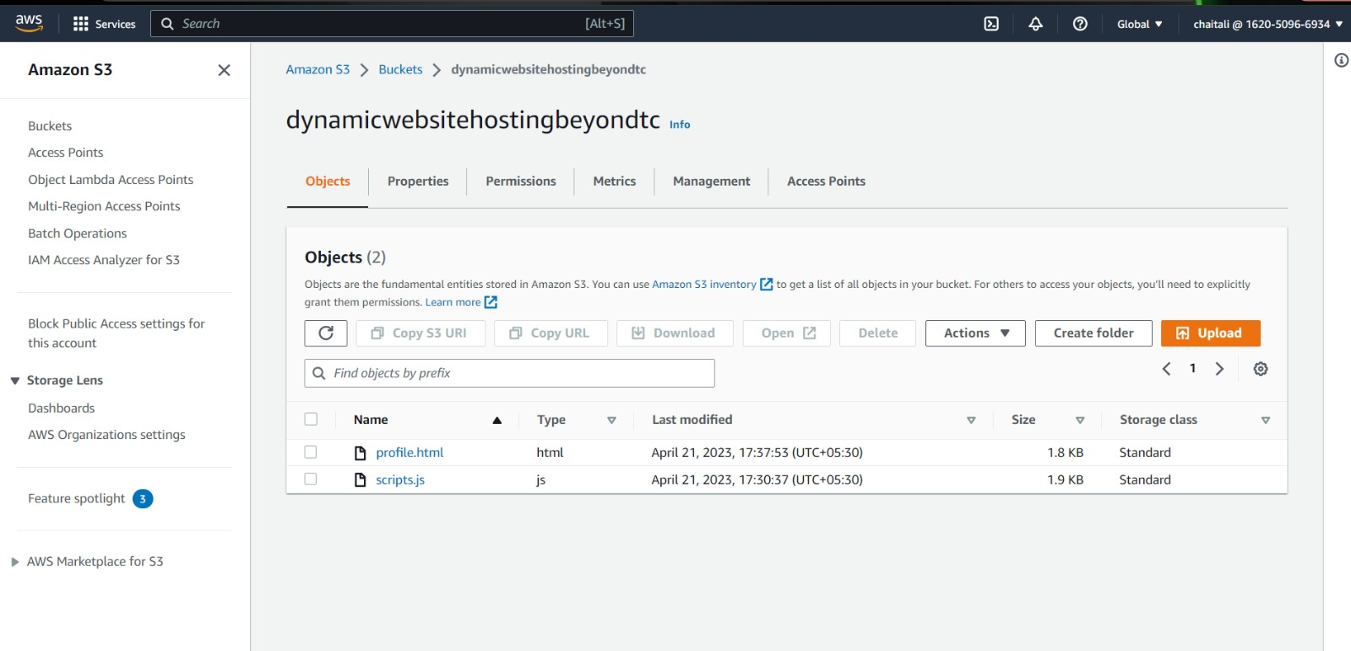

Fig. 6.1 S3 Bucket ‘dynamicwebhostingbeyondtc’ is created

The above screenshot shows the S3 bucket created for the Employee Profile Website project using AWS Cloud. The bucket name is 'employee-profile-bucket' and it stores the static assets of the website, including HTML and JavaScript files. The bucket is configured to allow public access, and the website endpoint is enabled to serve the website content through the CloudFront distribution. The bucket also stores the profile images uploaded by users, which are then processed and saved to the DynamoDB database by the Lambda function.

9
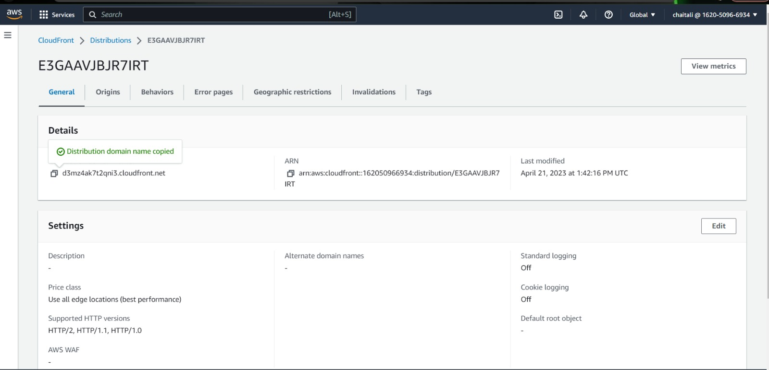

Fig. 6.2

The screenshot displays a CloudFront distribution that has been created for the Employee Profile website project using AWS Cloud. The distribution was set up because the project was previously saved in an S3 bucket that had public access. To secure the bucket and its contents, different policies were implemented.
The image also shows the CloudFront distribution domain name link, which will be used to access the employee profile website, if we click on the link the HTML page will be displayed but it won’t work because the lambda function is not created yet. By using this domain link, the website can be cached at edge locations around the world, reducing latency and improving user experience. In addition, different policies have been implemented to secure the website.

10
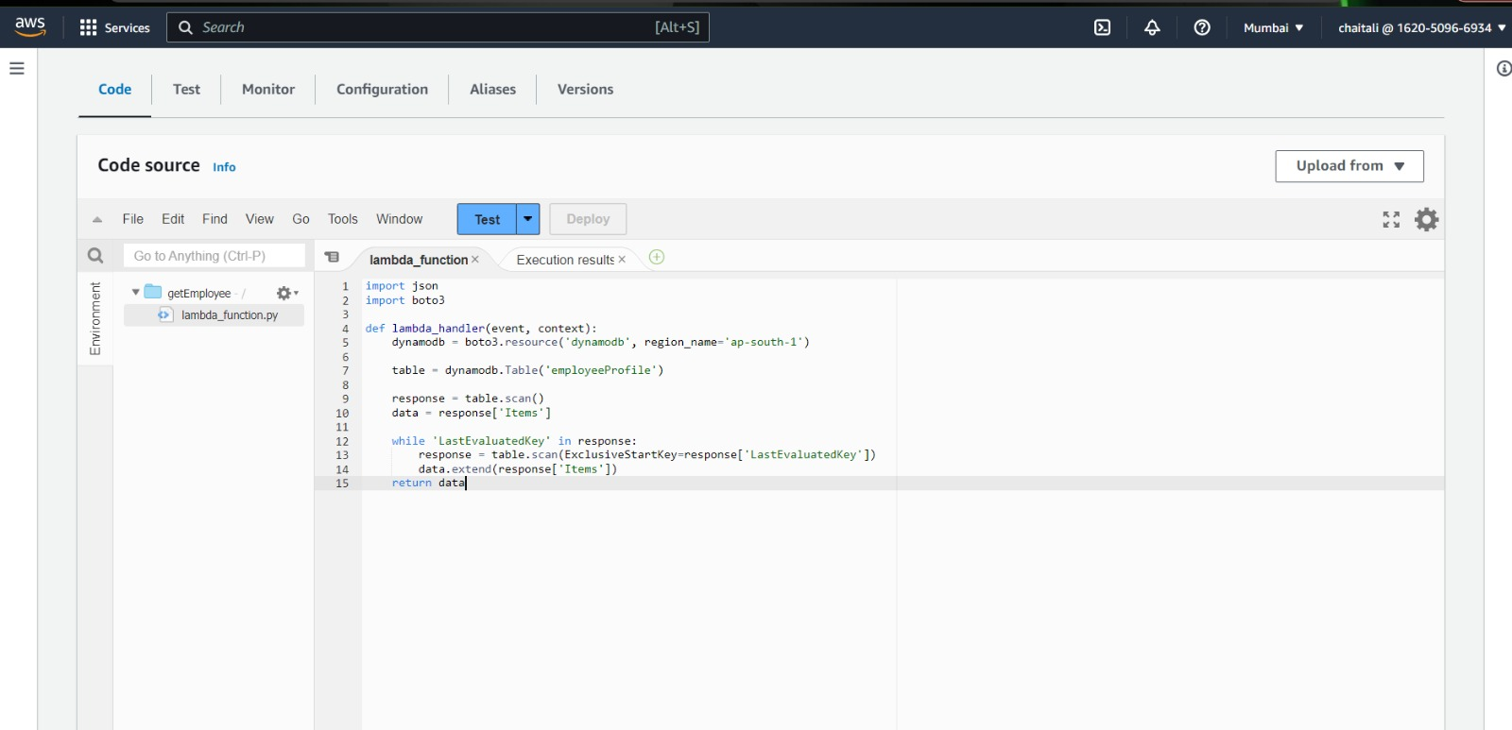
Fig. 6.3 get Lambda function is created.

The image shows a Lambda function that has been created for the website. The Lambda function was created to perform certain tasks when specific events occur, such as when a user saves or views an employee profile. In this case, the Lambda function was created to handle the "save" and "view" events. When a user saves an employee profile, the Lambda function is triggered and performs the necessary actions, such as validating the data and storing it in a database. When a user views an employee profile, the Lambda function retrieves the data from the database and displays it to the user.

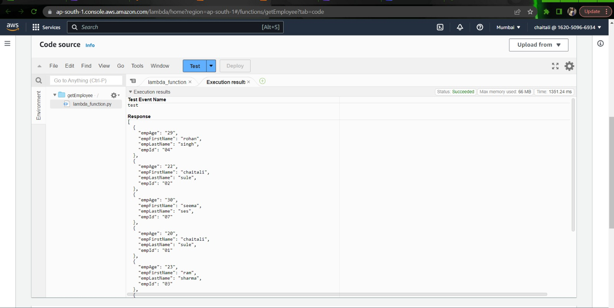
Fig. 6.4 Displays execution results of the lambda get function
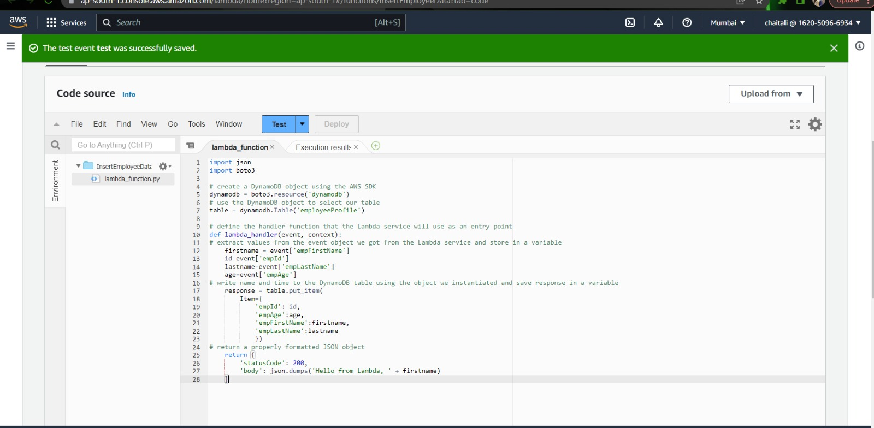
Fig. 6.5 insert Lambda function is created.

The image shows an Insert Lambda function that has been created for an employee profile website project using AWS Cloud. The Insert Lambda function was created to handle the insertion of new employee profile data into a database.
When a user saves a new employee profile, the Insert Lambda function is triggered and performs several tasks. First, it validates the data provided by the user to ensure that it meets certain criteria, such as data type and length. Second, it connects to the database and inserts the new data into the appropriate tables. Finally, it returns a response to the user indicating that the insertion was successful or provides an error message if the insertion failed.

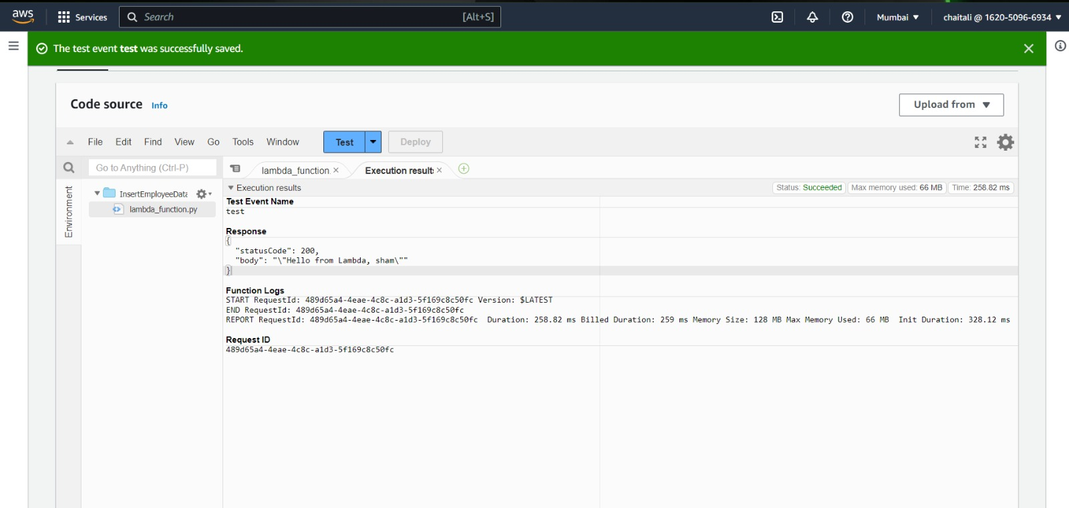
Fig. 6.6 Displays execution results of the lambda insert function

12
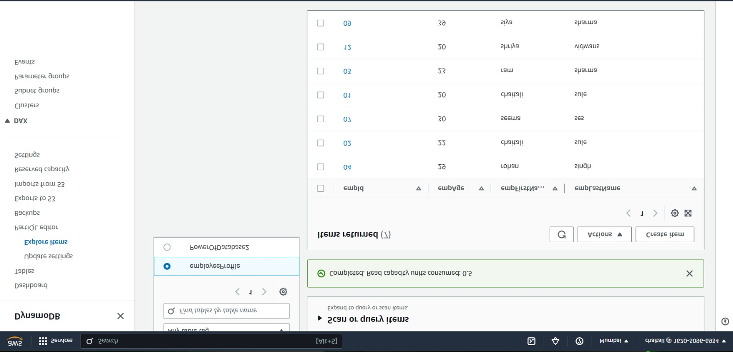

Fig. 6.7 Dynamo database created and entries are displayed

The image shows a DynamoDB database that has been created and connected to a Lambda function for an employee profile website project using AWS Cloud. The database is used to store employee profile data that is inserted and retrieved by the Lambda function. The Lambda function is connected to the DynamoDB database and is used to insert, retrieve and manipulate the data stored in the database. When a user saves a new employee profile, the Insert Lambda function is triggered, and it validates and inserts the data into the DynamoDB database. Similarly, when a user views an employee profile, a Retrieve Lambda function is triggered, which retrieves the data from the DynamoDB database and displays it to the user.

13
Fig. 6.8 GET and POST API Gateway methods have been setup
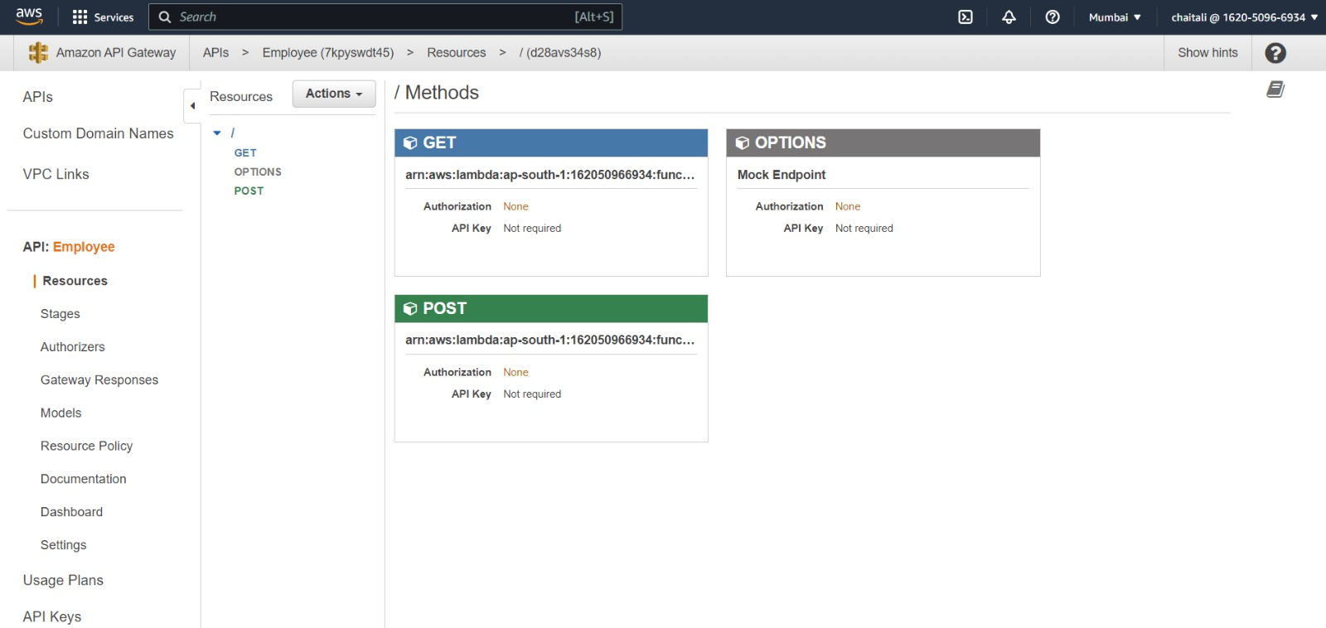

The image shows the configuration of the GET and POST API Gateway methods that have been set up for an employee profile website using AWS Cloud. These API Gateway methods are used to connect the Lambda functions to the database and provide an interface for users to access and manipulate the employee profile data.
The GET method is used to retrieve employee profile data from the database. When a user requests to view an employee profile, the GET method is triggered, and it calls the Retrieve Lambda function. The function retrieves the data from the database and returns it to the user through the API Gateway.
The POST method is used to insert new employee profile data into the database. When a user saves a new employee profile, the POST method is triggered, and it calls the Insert Lambda function. The function validates the data and inserts it into the database.
Using API Gateway to connect the Lambda functions to the database for this project provides several benefits. First, it provides a secure and scalable way to interact with the Lambda functions and the database. Second, it provides a simple and standardized interface for users to access and manipulate employee profile data. Finally, it allows for easy monitoring and management of the project's API usage.

14
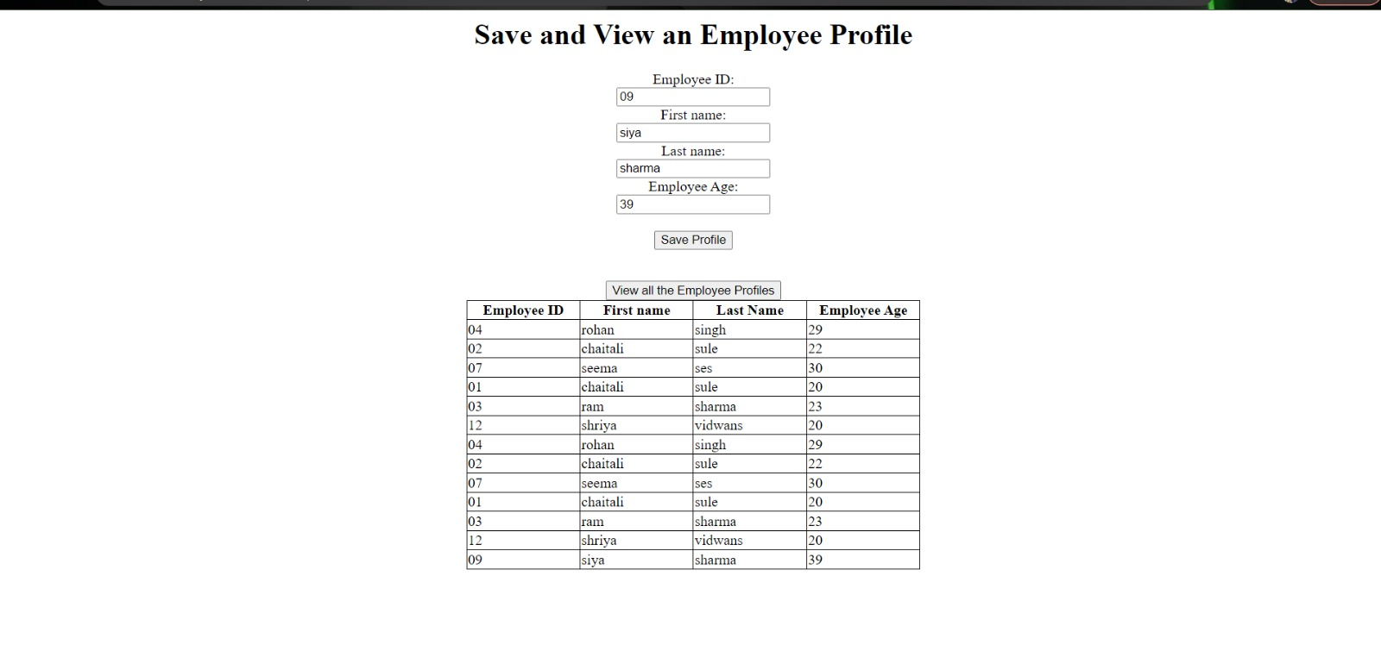

Fig. 6.9 Frontend displaying the working website

15
Learning Outcome

- Familiarity with cloud-based development platforms: Building a web application on AWS cloud requires a deep understanding of the various services provided by AWS. By building this application, developers can gain familiarity with cloud-based development platforms like AWS Amplify and learn how to leverage these services to build and deploy scalable, secure, and responsive applications.

- Serverless computing: AWS Lambda is a serverless computing service that allows developers to run code without managing servers. By building this application, developers can learn how to leverage the serverless computing model to build and deploy applications that can scale automatically and are highly available.

- Secure access management: AWS IAM allows developers to manage access to AWS resources securely. By building this application, developers can learn how to configure IAM roles and policies to grant access to specific AWS resources and manage access to those resources securely.

- Building APIs: AWS API Gateway is a fully managed service that makes it easy to create, deploy, and manage APIs at any scale. By building this application, developers can learn how to build and deploy APIs on AWS API Gateway and expose these APIs to the internet securely.

- NoSQL database management: AWS DynamoDB is a fully managed NoSQL database service that provides fast and predictable performance with seamless scalability. By building this application, developers can learn how to leverage DynamoDB to store and retrieve data for their applications and manage the database securely.

16

